Telemedicine Information and Instructions:

We are excited to offer you remote visits via doxy.me.

These visits are HIPAA compliant and your privacy will be respected in the same manner as if you were in the office being seen. TeleVisits are covered by most insurance companies. Contact your insurance provider if you any questions regarding your coverage. No payments will be collected at the time of the visit. You will be billed for any fees that are patient responsibility.

These visits are for reasons that do not require a physical exam other than a visual inspection. Your provider has made their best judgement that the visit is appropriate to be done via TeleVisit. However, should any information arise during the encounter that your provider believes requires an in-person exam, they will indicate as such and will have staff schedule you for an appropriate in person appointment.

Before your appointment:

* Have a computer or smart device available that has web cam capabilities and the web cam is enabled
* Have Google installed on the device that you will be using for your visit
* Make sure you have good internet connectivity
* Have an active email address that you have access to

How to Connect:

1. Provider will request a TeleVisit for you
2. A staff member will schedule you for a TeleVisit (You may be scheduled for a Telephone Evaluation if you do not have access to a webcam device)
3. 10 minutes prior to your appointment time, log into your email account
4. Your provider will email you the invitation for the Telemedicine Meeting
5. Click on the link in the email to join
6. When prompted, enter your name and click Check In
7. You may be prompted to enable your camera and microphone. Please make sure you give permission for these to be accessed.
8. You will be added to the provider’s virtual waiting room
9. Your provider will start the call and you will see them on your screen, and they will see you
10. Your provider will complete your visit in the same manner as if you were sitting fac-to-face, in-person
11. You provider will end the call once the visit is complete

\*Please note: Just as the providers sometimes can run behind in their schedules in the office, they may run behind for televisits as well. Please give up to 10 minutes past your appointment time for the televisit invitation to come through to your email. If, at that time, you have not received your invitation, please all the office.

Telemedicine Meeting Invite example:

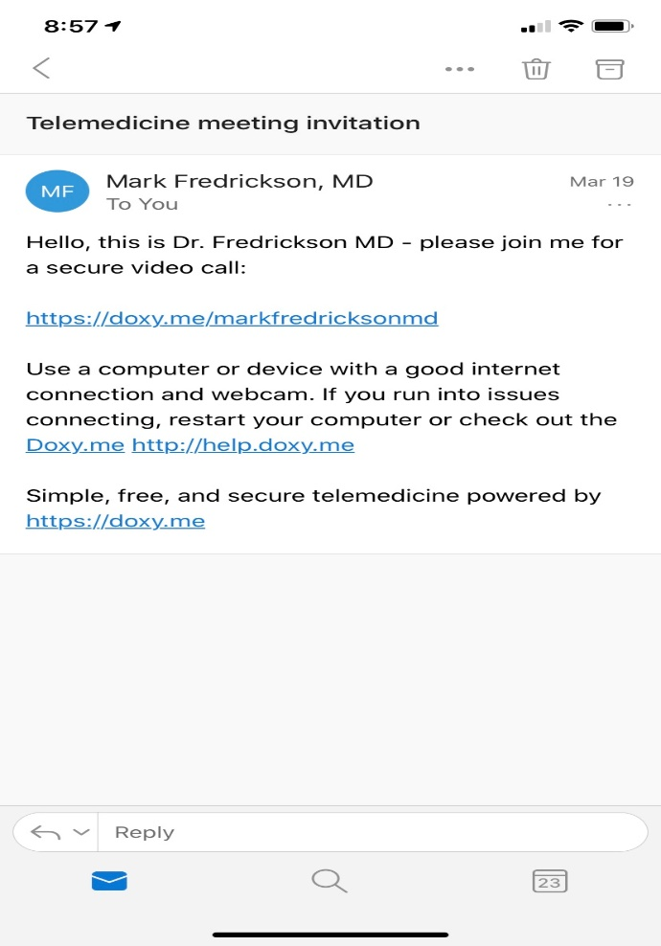

Check-In Screen example:

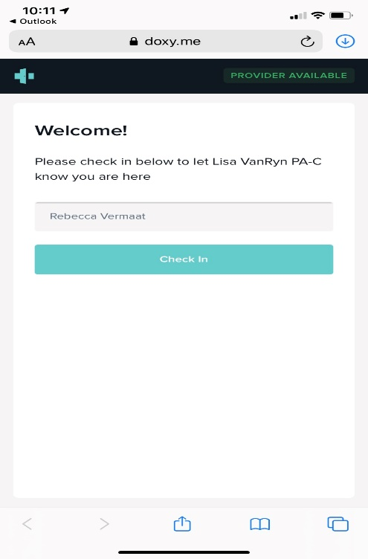

Permissions Screen example:

